Gap Analysis:
Nursing Care of Dyspnea: The 6th Vital Sign in Individuals with Chronic Obstructive Pulmonary Disease (COPD)2010
Work Sheet

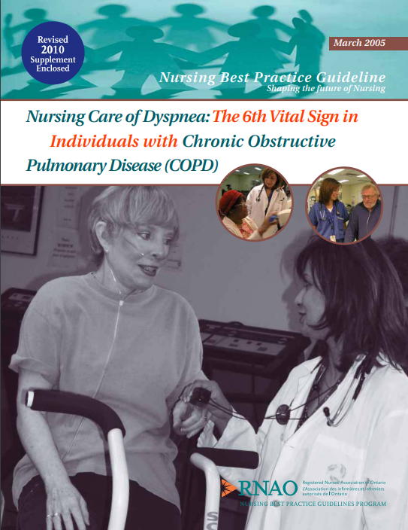
BPG Cover image
This guideline can be downloaded for free at:
https://rnao.ca/sites/rnao-ca/files/Nursing_Care_of_Dyspnea_-The_6th_Vital_Sign_in_Individuals_with_Chronic_Obstructive_Pulmonary_Disease.pdf
The RNAO Leading Change Toolkit 3rd Edition
https://rnao.ca/leading-change-toolkit

Date Completed:
Team Members participating in the Gap Analysis:

RNAO Healthy Work Environment Best Practice Guideline Recommendations | Met | Partially Met | Unmet | Notes  (Examples of what to include: is this a priority to our home, information on current practice, possible overlap with other programs or partners)
Recommendations
Assessment
1.0 Nurses will acknowledge and accept the patients’ self-report of dyspnea (IV)
1.1 All individuals identified as having dyspnea related to COPD will be assessed appropriately. Respiratory assessment should include:
■ Level of dyspnea
● Present level of dyspnea
● Present dyspnea should be measured using a quantitative scale such as a visual analogue or numeric rating scale
■ Usual level of dyspnea
● Usual dyspnea should be measured using a quantitative scale such as the Medical Research Council (MRC) Dyspnea Scale
■ Vital signs
■ Pulse oximetry
■ Chest auscultation
■ Chest wall movement and shape/abnormalities
■ Presence of peripheral edema
■ Accessory muscle use
■ Presence of cough and/or sputum
■ Ability to complete a full sentence
■ Level of consciousness (IV)
1.2 Nurses will be able to identify stable and unstable dyspnea, and acute respiratory failure. (IV)
1.3 Every adult with dyspnea who has a history of smoking and is over the age of 40 should be screened to identify those most likely to be affected by COPD. As part of the basic dyspnea assessment, nurses should ask every patient:
■ Do you have progressive activity-related shortness of breath?
■ Do you have a persistent cough and sputum production?
■ Do you experience frequent respiratory tract infections?
(IV)
1.4 For patients who have a history of smoking and are over the age of 40, nurses should advocate for spirometric testing to establish early diagnosis in at risk individuals. (IV)
COPD Dyspnea Interventions/Education
2.0 Nurses will be able to implement appropriate nursing interventions for all levels of dyspnea including acute episodes of respiratory distress:
■ Acknowledgement and acceptance of patients’ self-report of present level of dyspnea
■ Medications
■ Controlled oxygen therapy
■ Secretion clearance strategies
■ Non-invasive and invasive ventilation modalities
■ Energy conserving strategies
■ Relaxation techniques
■ Nutritional strategies
■ Breathing retraining strategies
(IV)
2.1 Nurses must remain with patients during episodes of acute respiratory distress. (IV)
2.2 Smoking cessation strategies should be instituted for patients who smoke:
■ Refer to RNAO (2003a) guideline, Integrating Smoking Cessation into Daily Nursing Practice.
■ Use of nicotine replacement and other smoking cessation modalities during hospitalization for acute exacerbation.
(IV)
Medications
3.0 Nurses should provide appropriate administration of the following pharmacological agents as prescribed:
■ Bronchodilators (Level of Evidence = 1b)
● Beta 2 Agonists
● Anticholinergics
● Methylxanthines
■ Oxygen (Level of Evidence = 1b)
■ Corticosteroids (Level of Evidence = 1b)
■ Antibiotics (Level of Evidence = 1a)
■ Psychotropics (Level of Evidence = IV)
■ Opioids (Level of Evidence = IV)
3.1 Nurses will assess patients’ inhaler device technique to ensure accurate use. Nurses will coach patients with sub-optimal technique in proper inhaler device technique. (Ia)
3.2 Nurses will be able to discuss the main categories of medications with their IV patients including:
■ Trade and generic names
■ Indications
■ Doses
■ Side effects
■ Mode of administration
■ Pharmacokinetics
■ Nursing considerations
Vaccination
3.3 Annual influenza vaccination should be recommended for individuals who do not have a contraindication. (Ia)
3.4 COPD patients should receive a pneumococcal vaccine at least once in their lives (high risk patients every 5 to 10 years).
(IV)
Oxygen Therapy
4.0 Nurses will assess for hypoxemia/hypoxia and administer appropriate oxygen therapy for individuals for all levels of dyspnea. (1b-IV)
Disease Self-Management
5.0 Nurses should support disease self-management strategies including:
■ Action plan development (Level of Evidence = 1b)
● Awareness of baseline symptoms and activity level
● Recognition of factors that worsen symptoms
● Early symptom recognition of acute exacerbation/infection
■ End-of-life decision-making/advanced directives (Level of Evidence = IV)
5.1 Nurses should promote exercise training (IV)
5.2 Nurses should promote pulmonary rehabilitation (Ia)
Education Recommendation
6.0 Nurses working with individuals with dyspnea related to COPD will have the appropriate knowledge and skills to:
■ Recognize the importance of individual’s self report of dyspnea
■ Provide COPD patient education including:
● Smoking cessation strategies
● Pulmonary rehabilitation/exercise training
● Secretion clearance strategies
● Breathing retraining strategies
● Energy conserving strategies
● Relaxation techniques
● Nutritional strategies
● Role/rationale for oxygen therapy
● Role/rationale for medications
● Inhaler device techniques
● Disease self-management and action plans
● End-of-life issues
■ Conduct appropriate referrals to physician and community resources
(IV)
Organization & Policy Recommendations
7.0 Organizations must institutionalize dyspnea as the 6th vital sign (IV)
7.1 Organizations need to have in place COPD educators to teach both nurses and patient (IV)
7.2 Organizations need to ensure that a critical mass of health professionals are educated and supported to implement this guideline in order to ensure sustainability (IV)
7.3 Organizations will ensure sufficient nursing staff to provide essential care, safety and support for individuals with all levels of dyspnea. (IV)
7.4 Organizations should have available sample medication delivery devices, spacer devices, sample templates of action plans, visual analogue scales, numeric rating scales, MRC scales and patient education materials. (IV)
7.5 Organizations need to have in place best practice guideline specific strategies to facilitate implementation. Organizations may wish to develop a plan for implementation that includes:
■ A process for the assessment of the patient population (e.g., numbers, clinical diagnostic practices, co-morbidities, average length of stay) of individuals usually cared for in their institution that are living with dyspnea related to COPD.
■ A process for the assessment of documentation practices related to the monitoring of dyspnea (usual and present dyspnea and dyspnea related therapies (e.g., SPO2).
■ A process for the evaluation of the changes in the patient population and documentation strategies pre- and post-implementation.
■ A process for the assessment of policies supporting the care of individuals living with dyspnea related to COPD. (IV)
7.6 Organizations need to develop specific pre-implementation and outcome markers to monitor the impact of the implementation of this guideline on the care of individuals with dyspnea related to COPD. Organizations may wish to evaluate:
■ Nursing knowledge base pre- and post-implementation.
■ Length of time between acute exacerbations of COPD (AECOPD) for specific individuals (perhaps globally represented by the number of acute care admissions and/or use of acute care resources over time pre- and post-implementation).
■ Development of documentation strategies to monitor and enhance care of individuals living with dyspnea related to COPD (integration of usual and present dyspnea on vital sign records within the institution).
■ Development of policies institutionalizing an education program for nurses caring for individuals living with dyspnea related to COPD. (IV)
7.7 Nursing best practice guidelines can be successfully implemented only where there are adequate planning, resources, organizational and administrative support. Organizations may wish to develop a plan for implementation that includes:
■ An assessment of organizational readiness and barriers to education.
■ Involvement of all members (whether in a direct or indirect supportive function) who will contribute to the implementation process.
■ Dedication of a qualified individual to provide the support needed for the education and implementation process.
■ Ongoing opportunities for discussion and education to reinforce the importance of best practices.
■ Opportunities for reflection on personal and organizational experience in implementing guidelines.
In this regard, RNAO (through a panel of nurses, researchers and administrators) has developed the Toolkit: Implementation of Clinical Practice Guidelines, based on available evidence, theoretical perspectives and consensus. The RNAO strongly recommends the use of this Toolkit for guiding the implementation of the best practice guideline on Nursing Care of Dyspnea: The 6th Vital Sign in Individuals with Chronic Obstructive Pulmonary Disease (COPD). (IV)
Program /Services
8.0 Pulmonary rehabilitation programs must be available for individuals with COPD to enhance quality of life and reduce healthcare costs. (IA)
8.1 Palliative care services must be available for individuals living with COPD and their caregivers. (III)
8.2 Nursing research related to interventions for individuals with COPD must be supported. (IV)
8.3 All Nursing programs should include dyspnea associated with COPD as one context for learning core curricula concepts.
(IV)
8.4 Funding regulations for oxygen therapy must be revisited to include those individuals with severe dyspnea, reduced ventilatory capacity and reduced exercise tolerance who do not qualify under the current criteria. (IV)

